**Floor Scrubbers, Polisher & Buffers.**

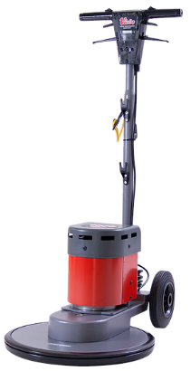 **Victor Contractor 450 High Speed £609.00 Net**

The Victor Contractor rotary machine is an extremely cost-effective machine for maintaining floors.

This high-speed machine is best suited to scrubbing applications on hard floors and bonnet mopping on carpets, also polishing and spray cleaning hard floors.

Comes complete with a drive board. The Contractor 450 is used with 450 mm (17 inch) pads and can be fitted with the optional tank, scrubbing brush or shampoo brush.

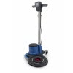**Numatic Hurricane HFM 1023 230 RPM £652.00 Net**

This 230 rpm, medium speed machine gives you the performance of two separate machines. It gives the right balance between scrubbing and polishing while using a power saving 1000W motor.

We recommend using with either a polyscrub or shampoo brush and a solution tank to dispense cleaning chemical when scrubbing. And if you are using the machine for polishing, we would suggest using an additional weight to provide extra downforce as this is a lightweight machine.

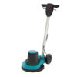**Truvox Orbis 200 Rotary Scrubber 15” £563.00 Net**

High pad / brush pressure for effective cleaning

Ergonomic design for excellent movement

Safety measures – thermal cut-out

Robust floor cleaner – no corrosion

Conveniently placed, easy to use controls



***Orbis Rotary Scrubber Std £587.00 Net***

High pad / brush pressure for effective cleaning

Ergonomic design for excellent movement

Safety measures – thermal cut-out

Robust floor buffer – no corrosion

Conveniently placed, easy to use controls

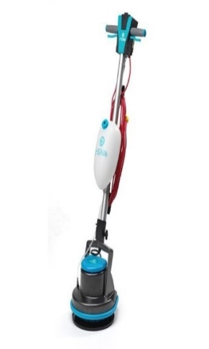 ***I-Scrub 30 EM 16*50 RPM Floor Scrubber £462.00 Net**

The I-SCRUB 30EM comes complete with a white pad, microfibre pad and pad holder, tank with pump. Orbital power. The future is now.  
Single-disc scrubbing has never been easier. Advanced orbital technology is based on 1650 RPM which simulated an orbital movement with no side forces.

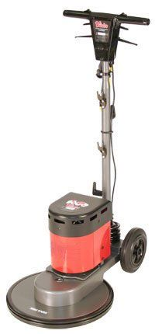 **Victor Contractor 400 High Speed Floor Scrubber £462.00 Net**

The Contractor Range of rotary machines offers unrivalled value and performance across a range of hard floor cleaning tasks including scrubbing, buffing, spray cleaning and bonnet mopping. At 230 rpm the Contractor Range provide the flexibility to effectively carry out most hard floor cleaning tasks. Fit the optional tank for scrubbing or bonnet mopping or change to pads to carry out stripping, scrubbing, mark removal and spray cleaning. As with all Victor machines the Contractor Range are delivered fully assembled and ready for use. A drive board is included so you can just attach the appropriate pad and start cleaning