**Vacuums (Upright & Tub)**

# [https://media.numatic.co.uk/images/gallery/tn/00004395.jpg](https://media.numatic.co.uk/images/gallery/md/00004395.jpg) **Henry HVR 160-11 Bagged Cylinder Vacuum Cleaner £119.00 Net**

With over 10 million Henrys made, and most still in use today, Henry really is the vacuum you can trust. Henry's great features make cleaning easy, including his super long-reach, trouble free, rewind 10 metre cable, huge capacity and on-board storage. Carpets, hard-floors, cars, stairs, DIY. . . Nothing beats a Henry for versatility.

With his huge capacity – up to x5 bigger than many bagless vacuums - Henry keeps you cleaning for longer.

A-rated, powerful and efficient cleaning technology from Henry's high-efficiency, long-life motor.

Henry HepaFlo bags - innovative self-seal tab locks all the dust in the bag, meaning emptying with no dust and no mess.

Versatile toolkit includes combination floor tool, round dusting brush, crevice tool, and upholstery tool with slide on brush.

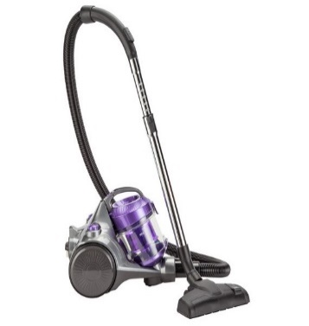**Bush VCS35B15KD Bagless Cylinder Vacuum Cleaner £51.58 Net**

Keep your home/office spick and span with this corded Bush bagless cylinder vacuum cleaner. It provides effective dust and dirt pick-up on all floor types and a power boost option for extra oomph. It features durable metal telescopic extension tubes that are made to last. The cleaner comes with a crevice nozzle that reaches even the trickiest of corners. The dustbin holds 1.3 litres and the HEPA filter traps small particles and pet dander, making it excellent for allergy sufferers.

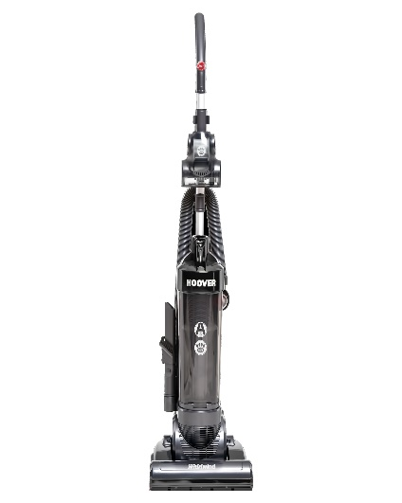**Hoover 2.5L Whirlwind Pets Upright Vacuum Cleaner £83.98 Net**

The Hoover WR02IC Whirlwind Pets upright vacuum cleaner is a simple to use bagless vacuum cleaner which will effortlessly clean carpets and hard floors without the need to adjust any settings. It is ideal for pet owners thanks to the Pets turbo brush which picks up much more pet hair than a standard vacuum cleaner.   
These vacuum weighs just under 4kg, this makes it light enough to comfortably carry up and down the stairs and also makes it extremely easy to manoeuvre around the house/office. With a 5M cord this vacuum offers a decent reach without the need to keep unplugging and finding a new socket to move around the room.

[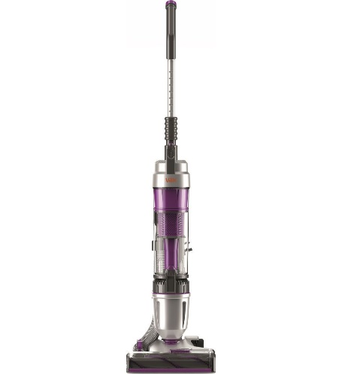](https://brain-images-ssl.cdn.dixons.com/1/5/10177251/u_10177251.jpg?_ga=2.59554797.1370625552.1551302131-1968183607.1549043228&_gac=1.15404930.1551362997.EAIaIQobChMI56u0t83e4AIViIbVCh3kxwGeEAQYAyABEgL0nvD_BwE)**VAX Air Stretch PetMax Upright Bagless Vacuum Cleaner £99.99 Net**  
  
Keep your home/office clean and tidy with the Vax **Air Stretch Pet Max U85-AS-Pme Upright Bagless Vacuum Cleaner**. It works on all your floors, whether it's carpet, hard floors or tiles. It delivers an efficient performance and comes with a range of useful accessories including an upholstery tool. This vacuum got what it takes to clean up all sorts of messes.  
**Cleans pet hair**.  
Pets give us so much joy, but they can also leave us with a lot of mess to clear up too! The **Air Stretch Pet Max** is ideal for households with furry friends running around - the included Turbo Tool attachment is perfect for sucking up pesky pet hair and ground in muck.

**[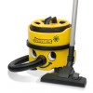](https://www.janitorialdirect.co.uk/media/product/db3/numatic-james-vacuum-cleaner-jvp180a-91e.jpg)Numatic James Vacuum Cleaner JVP180A £119.99 Net**

The'James' Numatic Cylinder Vacuum is unique for its caddy top that not only stores the power cable but can store your vacuum accessory tool kit as well as cleaning materials and products. Designed for simplicity coupled with superb power and performance enabling the 'James' vacuum to tackle whatever vacuuming job is required.

The 'James' Numatic Cylinder Vacuum has a large 8L capacity for continuous cleaning, four-wheel stability, giant filters coupled with two-stage Hepaflo dust bags which give you the best of all available filter options. Quick and efficient to use, and very simple to empty. Neat storage that packs away nicely with on-board wand and floor-tool storage.

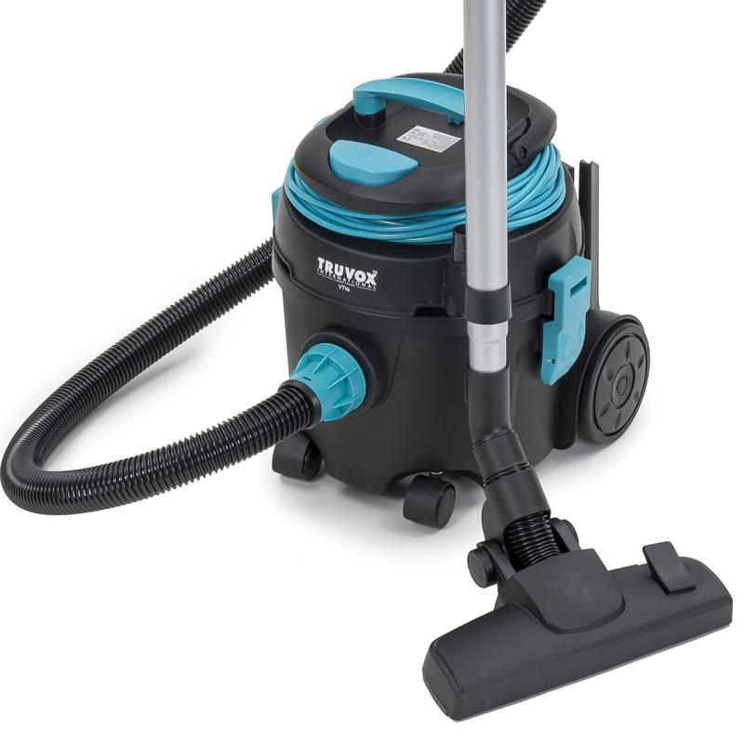**Truvox VTVe Commercial dry tub vacuum cleaner £86.40 Net**

**The VTVe is a high-performance, compact tub vacuum that has an A energy rating.   
This dry tub vacuum is ideal for nursing homes, offices and education facilities. The VTVe is designed to be compact and includes brush and crevice tools for improved cleaning in hard to reach and confined areas.**

Featuring a 3-stage filtration, including a HEPA 13 filter, the VTVe provides a high filtration of all particles that are 0.3 microns and larger

Weighing only 6kg the VTVe is light and maneuverable ideal for transporting between cleaning jobs

Tidy cable wrap storage to prevent tangling

11.5 litre capacity for high productivity and is inclusive of HEPA 13 fleece bag

Quick and easy to replace cord replacement system

For easy accessibility during use, the crevice and brush tools are stored at the rear of the machine

Handy wand holder for convenient machine storage